How to create a fillable form in Excel

Using Fillable forms in Excel allows you to collect data in a structured and organized manner. You can define the required fields and specify the type of data to be entered, such as text, numbers, or dates. This makes it easier to gather information from multiple users consistently.

The provided dataset consists of several fields representing company information. Each row represents a separate company entry. The form includes the following fields: Company Name, Company Type, Address, City, State, Postal Code, Country, and No. of Employees. We aim to transform the provided dataset into a user-friendly fillable form format.In today’s tutorial, we will learn how to do it.

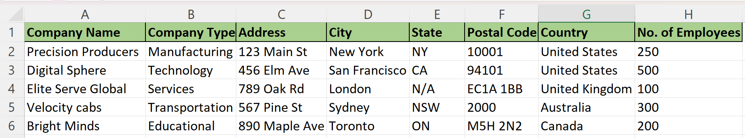

Two methods to create a fillable form are as follows:

## Method 1 – By using the VBA code

## Step 1 – Opening the VBA editor

* **Launch Excel** on your computer.
* **Open the workbook** in which you want to access the **VBA** **Editor** to **create a fillable form.**
* Go to the **"Developer" tab** in the Excel ribbon. If you **don't see the "Developer" tab**, you need to **enable it first.** To do so, **right-click on the Excel ribbon**, select **"Customize the Ribbon",** and check the box next to "Developer" in the list of tabs.
* In the **"Developer" tab,** click on the **"Visual Basic" button**. It is represented by an **icon that looks like a piece of paper with boxes on it** and is located in the **"Code" section** of the ribbon.
* Alternatively, you can use your **keyboard’s shortcut** **“Alt + F11”** to **directly open** the **VBA Editor.**
* **The VBA Editor** window **will now open,** showing the **Project Explorer pane** on the **left side.**
* In the **Project Explorer pane,** the **workbook’s VBA project** is listed with the workbook name. **Double-click** on it to **expand its contents.**
* **Within the expanded workbook project,** you will see a **list of worksheet modules**. **Look for "Sheet1"** and **double-click** on it to **open the VBA code** associated with **Sheet1.**



## Step 2 – Writing the code

* Simply **copy and paste** the following code in the code area.

Sub Open_Data_Form()

ActiveSheet.ShowDataForm

End Sub

* Then **press the ‘X’ button** or use shortcut key **“Alt+Q” to close** the **VBA Editor.**



## Step 3 – Inserting a shape and assigning macro to it

* Go to the **"Insert" tab** in the Excel ribbon.
* In the **"Illustrations" group,** click on the **"Shapes" button.** A **drop-down menu** will appear, showing **various shape options.**
* Select the desired shape from the menu. For example, **choose a rectangle shape** by clicking on it.
* Click and **drag on the worksheet to draw the shape** at your preferred location and size.
* With the shape still selected, **click inside it** to **activate the text editing** mode.
* Type **"CLICK HERE TO FILL FORM"** to add the **desired text to the shape.**
* To **format** the shape or the **text**, you can use the **various formatting options** available in the Excel ribbon, such as **font styles, colors, and alignments.**
* **Right-click** on the **newly inserted shape.** A **context menu** will appear.
* From the **context menu,** select **"Assign Macro."** This will **open** the **Assign Macro dialog box.**
* In the **Assign Macro dialog box,** **select** the **desired macro** from the list. For instance, we will select the macro named **“Sheet1.Open_Data_Form”.**
* Once you have **selected the macro,** **click** the **"OK" button** to **assign it** to the shape.



## Step 4 – Using the button to fill form

* Simply, **click** on the shape that we have inserted as a **button.**
* Then, a **dialogue box would appear** on your screen.
* Click on the **“New” option** within the dialogue box.
* Now, **fill the form** according to your preference.
* **Once you’ve filled** the form, close it by **clicking** **on the** **“Close” button.**



## Method 2 – By using Excel Templates

## Step 1 – Searching for Desired Template

* **Open** **Microsoft Excel** on your computer.
* **Click** on the **"File" tab** located in the **top left corner** of the Excel window.
* In the file menu, **select "New"** or "New Workbook" to create a new workbook.
* On the **"New" page,** you'll see **different template options**.
* To **browse the available templates,** you can either **scroll through the options** or **use the search bar** to find a specific template.
* We are going to search for **“forms”** in template search bar.



## Step 2 – Using the Template

* **Click on the template** that you want to use.
* **A preview of the template will appear** on the the screen.
* **Once you've selected** a template, **click on the "Create"** or "Download" button (the specific wording may vary depending on your Excel version).
* The **selected template** will **open as a new workbook**, and you can **start working with it** immediately.
* **Make any necessary edits** or modifications to the **template** to **suit your needs.**

